Lab: The User Interface Architecture

In this lab, you will first explore the tools available for investigating the architecture of the user interface. Then, you will use the PCF Editor in Guidewire Studio to modify the order of fields in a page configuration file. Finally, you will deploy and verify your file changes.

Requirements

This lab requires that you use TrainingApp 8.0, Guidewire Studio 8.0, and a supported web browser. To view, edit, and delete various contacts, log in to TrainingApp as Alice Applegate. The default URL for TrainingApp is <http://localhost:8880/ab/ContactManager.do>. The login/password for Alice Applegate is aapplegate/gw.

1. Explore the page structure

In this exercise, you will explore the page structure of the summary page using the internal tools and the PCF Editor.

Tasks

1. Open Guidewire Studio
2. Run the TrainingApp project
3. Use the main menu, toolbar, or keystroke to run the server.
4. Verify that the Run Console tab shows ***** ContactManager ready *****.
5. Log in to TrainingApp
6. Log in as Alice Applegate.
7. View the William Andy Summary
8. Search for William Andy.
9. In the search results list view, navigate to the William Andy contact.
10. Open the Location Info window
11. Use ALT+SHIFT+I to open the Location Info window.

ABContactSummaryPage

Write it down

Review the file structure in the dialog. What is the parent PCF of the FlagEntriesLV.pcf?

|  |
| --- |
| DetailView "ABContactSummaryDV" |

1. Open the Widget Inspector window
2. Use ALT+SHIFT+W to open the Widget Inspector window.

Write it down

Review the Page Include Structure. What is the value of anABContact variable?

|  |
| --- |
| William Andy |

Review the Page Widget Structure. Compare the id and renderId values of the ScreenWidget. How does the renderId value differ from the id value?

|  |
| --- |
| Id tiene el id del widget mientras referId tiene el nombre con la gerarquia complete del widget |

1. Open the page in Guidewire Studio
2. Use ALT+SHIFT+E to open the page in Guidewire Studio.
3. In the canvas, hide included sections.

Write it down

Review the ABContactSummaryPage.pcf structure in the Structure tab. What is the parent widget of the Toolbar widget?

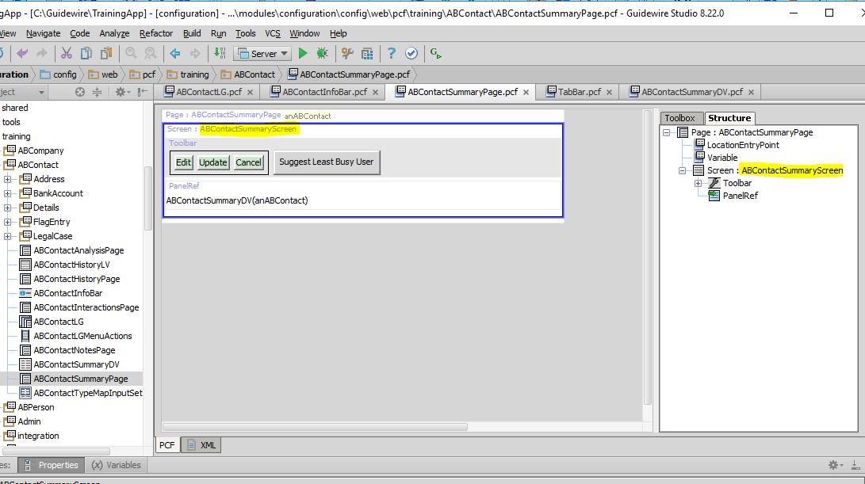

|  |
| --- |
| screen " ABContactSummaryScreen" |

1. Navigate to the ABContactSummaryDV.pcf
2. In the canvas, show included sections.

Write it down

Review the ABContactSummaryDV.pcf in the canvas. How are you able to distinguish included sections from the widgets specified in the file itself?

|  |
| --- |
| Por el color |

1. Modify the summary details view

In this exercise, you will modify the ABContactSummaryDV.pcf file that you have already open in the PCF Editor in Guidewire Studio.

Tasks

1. Modify the order of the widgets in Basic Information
2. Move the CreateTime widget below the AssignedUser widget.
3. From the Toolbox, add an input divider between AssignedUser and ContactID.

Verification

1. Reload the PCF changes
2. In TrainingApp, reload the changes to the PCF file(s).
3. Verify the changed order of the widgets and the addition of the input divider.

|  |  |
| --- | --- |
|  | Stop and ask your instructor to review your completed lab. |